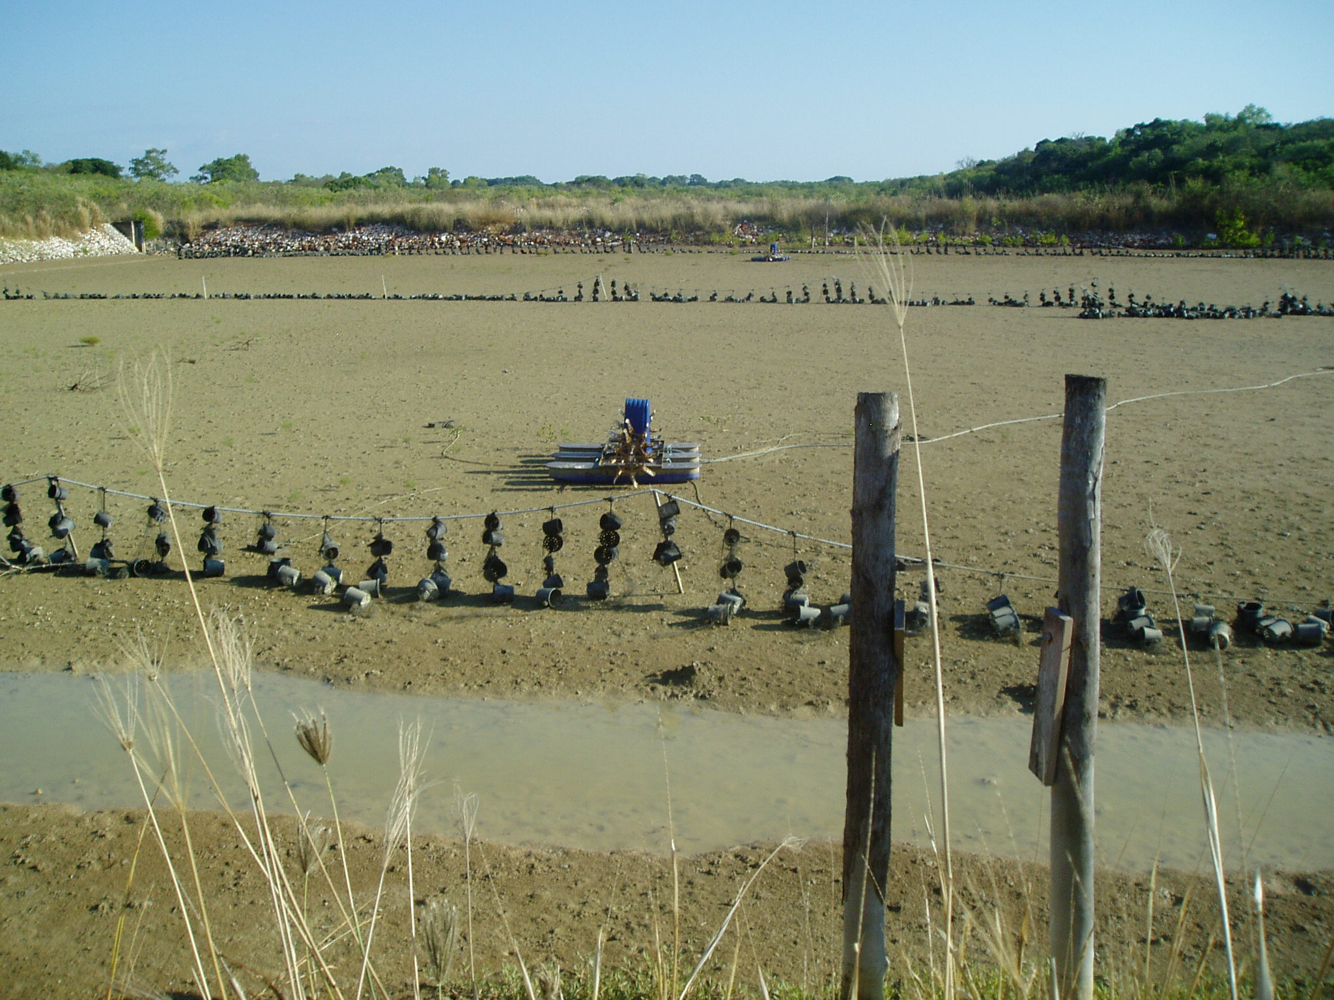
Above: Abandoned crab farm ponds on the Kulaluk lease in 2011. Photo Bill Day
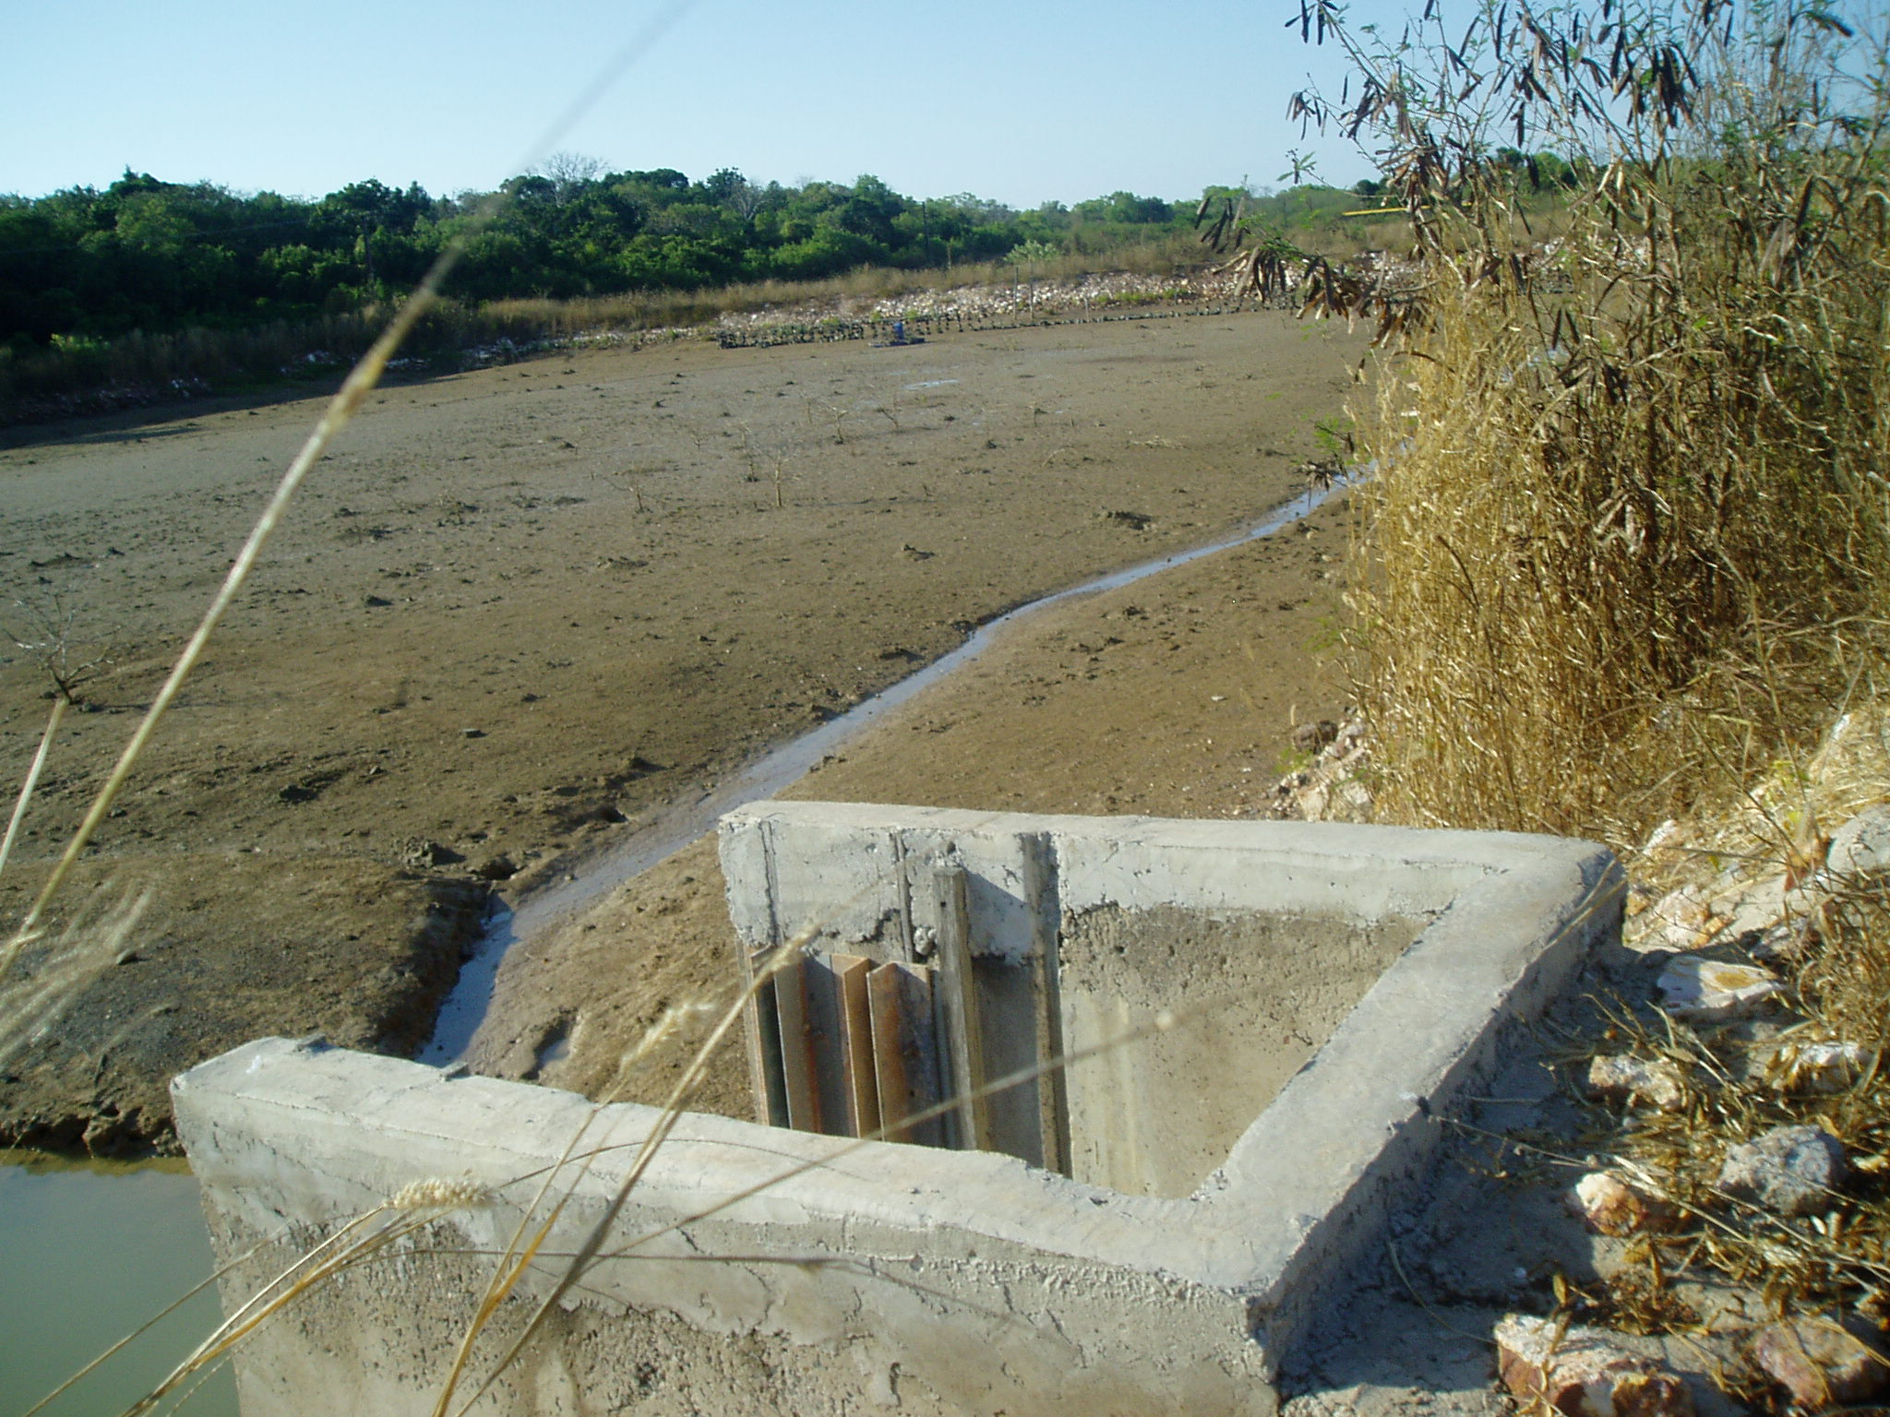
Above: Abandoned infrastructure and pond on the Kulaluk lease in 2011. Photo Bill Day.
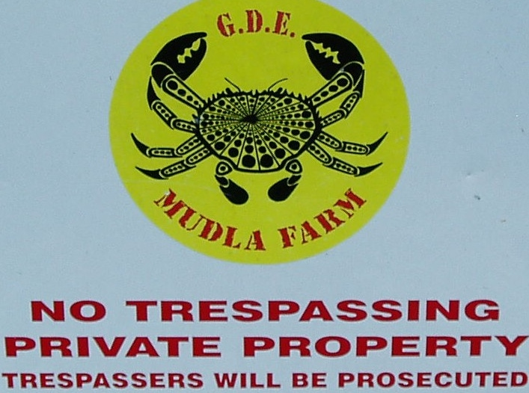

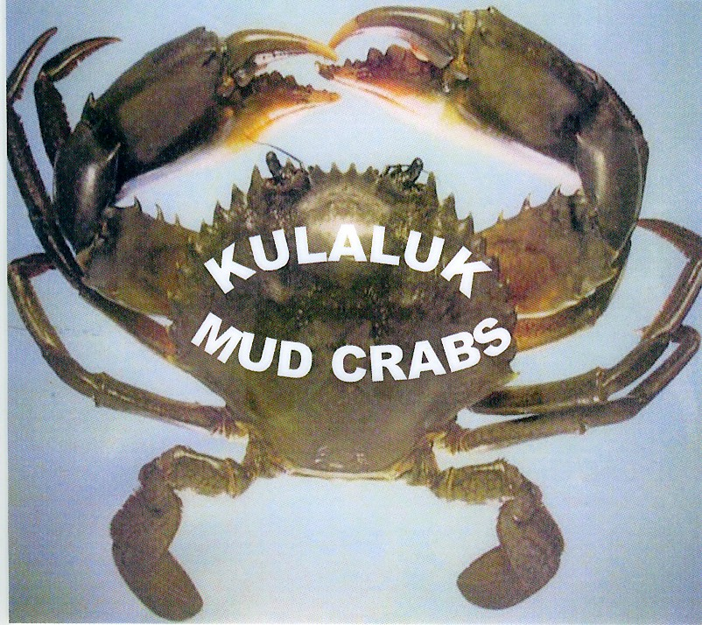
Above – Kulaluk Gate sign. Below - Logo found in abandoned demountable on site.

